* Project Description

**The open-source project I decided to contribute to was the Microsoft Calculator on GitHub. The issue I found and implemented was a feature request in which I added parentheses support to the standard calculator.**

* GitHub file walk through

*overview of files changed and where I found them*

* Contribution walkthrough
  + Describe your contribution. What did you do? Include both a link (use a URL shortener like bit.ly to keep it short) and screenshot/transcript of what you did here. Make sure to describe clearly what you did, vs. what others did.
    - What worked

Link:

**I added new right and left parentheses button objects in the StandardOperatorsPanel.cs file. I then gave these objects functionality by writing a function for mouse input in the StandardModeFunctionalTests.cs file.**

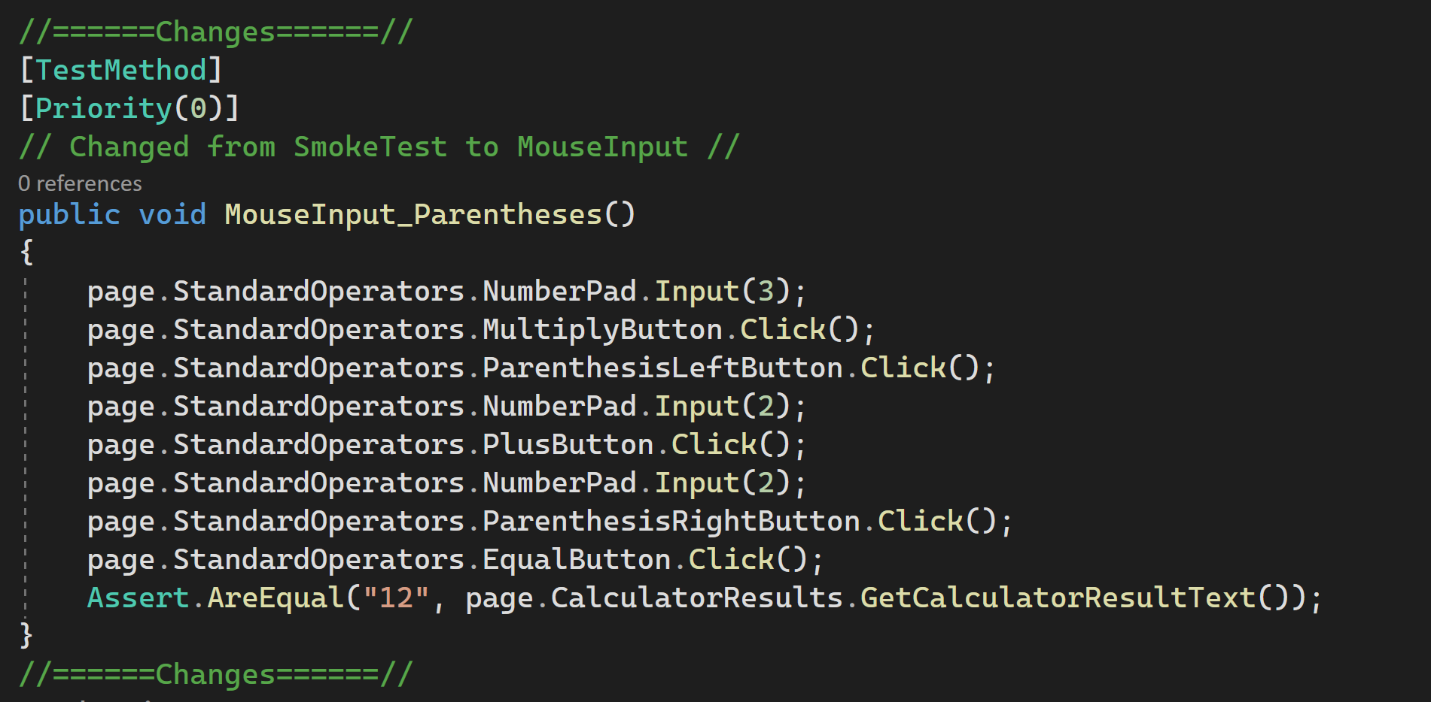

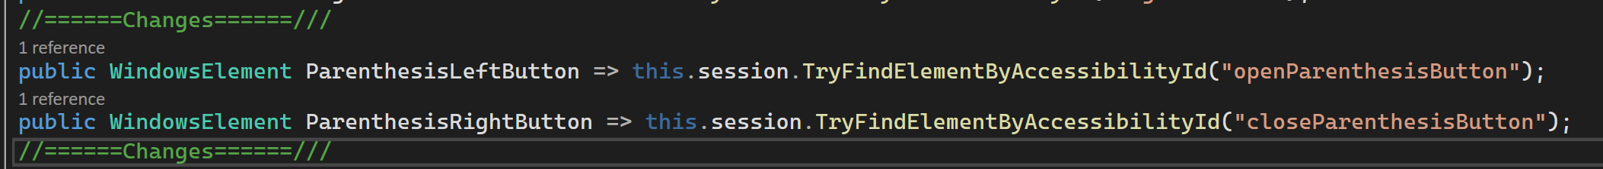

* + What turned out the way you expected, as described in the docs or textbook, or things that worked out in your favor.
    - What did not work

**Downloading the required software and cloning the repository was easy since I have done these things many times before. Creating the required functions for the code was also easy since the program I worked with already had many built in functions I could work with to implement my feature.**

* + Roadblocks, unexpected problems, etc. Discuss what they were and how you overcame them, if you did.
    - What I learned and what will you do different in the future, etc.

**Finding the files I needed to alter was the most troublesome part of the project. This took longer than expected and ultimately led me to be unable to figure out how to run the program UI and make sure my changes were implemented correctly. In the future I would find an easier project to work with since this one was much to difficult given the timeline I was given to complete the project.**